Postoperative Complications and Associated Outcomes Following Intestinal Stoma Formation: A Systematic Review and Exploratory Meta-Analysis
La Rangki^{1*}, Kadek Ayu Erika², Rusdina Bte Ladju³
¹ Doctoral Program in Medical Science, Faculty of Medicine, Hasanuddin University, Makassar, Indonesia.
² Department of Pediatric Nursing, Faculty of Nursing Science, Hasanuddin University, Makassar, Indonesia.
³ Department of Pharmacology, Faculty of Medicine, Hasanuddin University, Makassar, Indonesia.
Author identifiers and contact details
La Rangki — Email: larangki@uho.ac.id; Telephone/WhatsApp: 081242338398; ORCID: 0000-0002-6713-7330; Scopus ID: 6772285.
Kadek Ayu Erika — Email: kadekayu@unhas.ac.id; Telephone/WhatsApp: 081342129855; ORCID: 0000-0001-6975-5264; Scopus ID: 57191058011.
Rusdina Bte Ladju — Email: rbteladju@med.unhas.ac.id; Telephone/WhatsApp: 089604230063; ORCID: 0000-0002-8616-2581; Scopus ID: 57193379383.
Corresponding author
La Rangki
Doctoral Program in Medical Science, Faculty of Medicine, Hasanuddin University, Makassar 90245, Indonesia.
Email: larangki@uho.ac.id
Telephone/WhatsApp: +62 812-4233-8398
ORCID: 0000-0002-6713-7330
Running title: Intestinal Stoma Outcomes
Manuscript type: Meta-Analysis
Abstract
This systematic review and exploratory meta-analysis synthesised evidence on postoperative complications, associated risk factors, and quality of life among patients with intestinal stomas. PubMed/MEDLINE, Scopus, and Web of Science were searched for peer-reviewed quantitative studies published from 2017 onward, and study selection followed PRISMA 2020. Of 295 records identified, 290 were screened, 70 reports were sought for retrieval, 64 were assessed for eligibility, and 12 studies were included; 11 contributed to the quantitative synthesis and one quality-of-life study was synthesised narratively. The exploratory meta-analysis yielded a pooled standardised effect estimate of 1.12 (95% CI 0.60–1.65; t(10)=4.80, p<0.001), with substantial heterogeneity (Q(10)=104.53, p<0.001; I²=86.98%). Intestinal stoma outcomes varied across clinical phases, stoma types, risk factors, and outcome definitions. The pooled estimate should therefore be interpreted as an exploratory statistical summary alongside outcome-specific findings rather than as a single universal clinical risk measure.
Keywords: Surgical Stomas; Ileostomy; Colostomy; Postoperative Complications; Risk Factors; Quality of Life
Introduction
Intestinal stoma formation creates a connection between the intestinal lumen and the abdominal wall to divert faecal or intestinal contents, either temporarily or permanently. It is used in colorectal cancer, inflammatory bowel disease, abdominal trauma, obstruction, perforation, anal sphincter dysfunction, and other conditions requiring intestinal diversion. Although stoma formation may be life-saving, postoperative morbidity remains substantial. Reported complication rates vary widely and include skin irritation, infection, necrosis, stenosis, prolapse, retraction, parastomal hernia, and nutritional disturbances associated with high-output stoma.^{1,2}
Complications may occur from the early postoperative period through long-term stoma care and subsequent closure. Preoperative stoma-site marking has been associated with fewer stoma and peristomal complications, including in emergency surgery.^{3,4} Risk is also influenced by patient characteristics, stoma type and location, abdominal-wall anatomy, treatment exposure, and postoperative clinical conditions.^{5–8}
Peristomal skin disorders are particularly important because leakage, pain, odour, embarrassment, and impaired appliance adhesion can directly affect daily functioning. Evidence has linked loop stoma, low stoma height, chemotherapy, and diabetes mellitus with peristomal skin disorders or worsening skin conditions.^{9–11} Late complications, including parastomal hernia and morbidity around stoma closure, also affect clinical outcomes and health-related quality of life.^{12–14}
Quality of life is a patient-centred outcome because living with a stoma may alter body image, dietary habits, sleep, work, social participation, sexual relationships, and perceived safety during routine activities. Reported determinants include stoma type, age, permanence of the stoma, perceived stress, physical symptoms, and social or functional conditions.^{15–18}
Existing syntheses have generally focused on individual preventive factors, specific complications, or quality-of-life outcomes rather than the broader continuum of postoperative morbidity.^{3,6,19,20} The present systematic review and exploratory meta-analysis therefore aimed to synthesise evidence on postoperative complications, associated risk factors, and quality of life among patients with intestinal stomas, while using a standardised quantitative synthesis to summarise study-level effects across clinically heterogeneous outcomes.
Methodology
This systematic review and exploratory meta-analysis followed the Preferred Reporting Items for Systematic Reviews and Meta-Analyses (PRISMA) 2020 statement for identification, screening, retrieval, eligibility assessment, and inclusion of studies.²¹ The review protocol was not registered in PROSPERO. The review question was structured using the Population, Intervention/Exposure, Comparison, and Outcome (PICO) framework, and the exploratory quantitative synthesis followed general principles of clinical meta-analysis described in the Cochrane Handbook.²²
Patients with intestinal stomas were the population; clinical, technical, or treatment-related factors were the exposures; patients without the relevant risk factor or reference groups were comparators; and postoperative complications or quality-of-life outcomes were the outcomes of interest. Eligible designs included prospective cohort, retrospective cohort, case-control, analytical cross-sectional, registry-based, and observational comparative studies. Reviews, systematic reviews, scoping reviews, meta-analyses, narrative reviews, editorials, letters, protocols, case reports, and case series were excluded from the primary synthesis. The review framework is presented in Table I.
Table I. PICO framework of the review
Component | Information
P (Population) | Patients with intestinal stoma, including ileostomy, colostomy, jejunostomy, enterostomy, loop stoma, end stoma, temporary stoma, or permanent stoma.
I (Exposure) | Clinical, technical, and treatment-related factors, including stoma type, emergency/elective surgery, stoma-site marking, diabetes mellitus, obesity, American Society of Anesthesiologists (ASA) score, chemotherapy, radiotherapy, loop/end stoma, and stoma height.
C (Comparison) | Patients without the relevant risk factor, reference groups, comparison stoma types, patients without complications, or patients with better quality-of-life outcomes.
O (Outcome) | Postoperative and stoma-related complications, peristomal skin complications, mucocutaneous separation, necrosis, retraction, prolapse, parastomal hernia, high-output stoma, stoma outlet obstruction, readmission, surgical-site infection, stoma closure/reversal complications, and quality of life.

PubMed/MEDLINE, Scopus, and Web of Science were searched for peer-reviewed articles published from 2017 onward in English and/or Indonesian. The initial search was conducted in February 2026 and was updated on 15 June 2026. The search was limited to studies published from 2017 onward to ensure that the review reflected contemporary surgical practice, stoma-care approaches, postoperative management, and recent evidence on stoma-related complications and patient outcomes. Search terms combined concepts for intestinal stoma and related procedures with postoperative or stoma-related complications, risk factors, predictors, odds ratios, confidence intervals, and quality of life using Boolean operators. The database-specific search strategies and records identified are presented in Table II.
Table II. Database search strategies and records identified
Database | Search strategy | Records
PubMed/MEDLINE | ("intestinal stoma" OR ostomy OR stoma OR ileostomy OR colostomy OR enterostomy) AND ("postoperative complications" OR "stoma-related complications" OR "peristomal skin complications" OR "mucocutaneous separation" OR "parastomal hernia" OR "high-output stoma" OR readmission OR "surgical site infection") AND ("risk factors" OR predictor OR determinants OR "odds ratio" OR "confidence interval" OR "quality of life" OR HRQoL OR "Stoma-QOL") | 92
Scopus | TITLE-ABS-KEY ("intestinal stoma" OR ostomy OR ileostomy OR colostomy OR enterostomy) AND TITLE-ABS-KEY ("postoperative complication" OR "stoma-related complication" OR "peristomal skin complication" OR "parastomal hernia" OR "high-output stoma" OR retraction OR prolapse OR necrosis OR readmission) AND TITLE-ABS-KEY ("risk factor" OR predictor OR determinant OR "quality of life" OR HRQoL OR "odds ratio" OR "confidence interval") AND PUBYEAR > 2016 | 118
Web of Science | TS=("intestinal stoma" OR ostomy OR ileostomy OR colostomy OR enterostomy) AND TS=("postoperative complication" OR "stoma-related complication" OR "peristomal skin complication" OR "mucocutaneous separation" OR "parastomal hernia" OR "high-output stoma" OR readmission OR "surgical site infection") AND TS=("risk factor" OR predictor OR determinant OR "quality of life" OR HRQoL OR "Stoma-QOL") | 85
Total | — | 295

The initial search yielded 295 records: 92 from PubMed/MEDLINE, 118 from Scopus, and 85 from Web of Science. After removal of 5 duplicate records, 290 records underwent title and abstract screening and 220 were excluded. Seventy reports were sought for retrieval; 6 could not be retrieved. Sixty-four full-text reports were assessed for eligibility, of which 52 were excluded: 18 did not report extractable statistical data; 10 did not have a population specific to patients with intestinal stoma; 9 did not report analysable risk factors; 7 did not clearly report complication or quality-of-life outcomes; and 8 had inappropriate study designs. Twelve studies were included in the systematic review. Eleven studies contributed to the quantitative meta-analysis, while the quality-of-life study was retained for narrative synthesis. The study-selection process is shown in Figure 1.
Duplicate records were identified and removed using EndNote. Three reviewers independently screened the titles and abstracts of the retrieved records and subsequently assessed potentially eligible full-text articles according to the predefined inclusion and exclusion criteria. Any disagreements regarding study eligibility were resolved through discussion and consensus among the reviewers.
Figure 1. PRISMA 2020 flow diagram of study selection
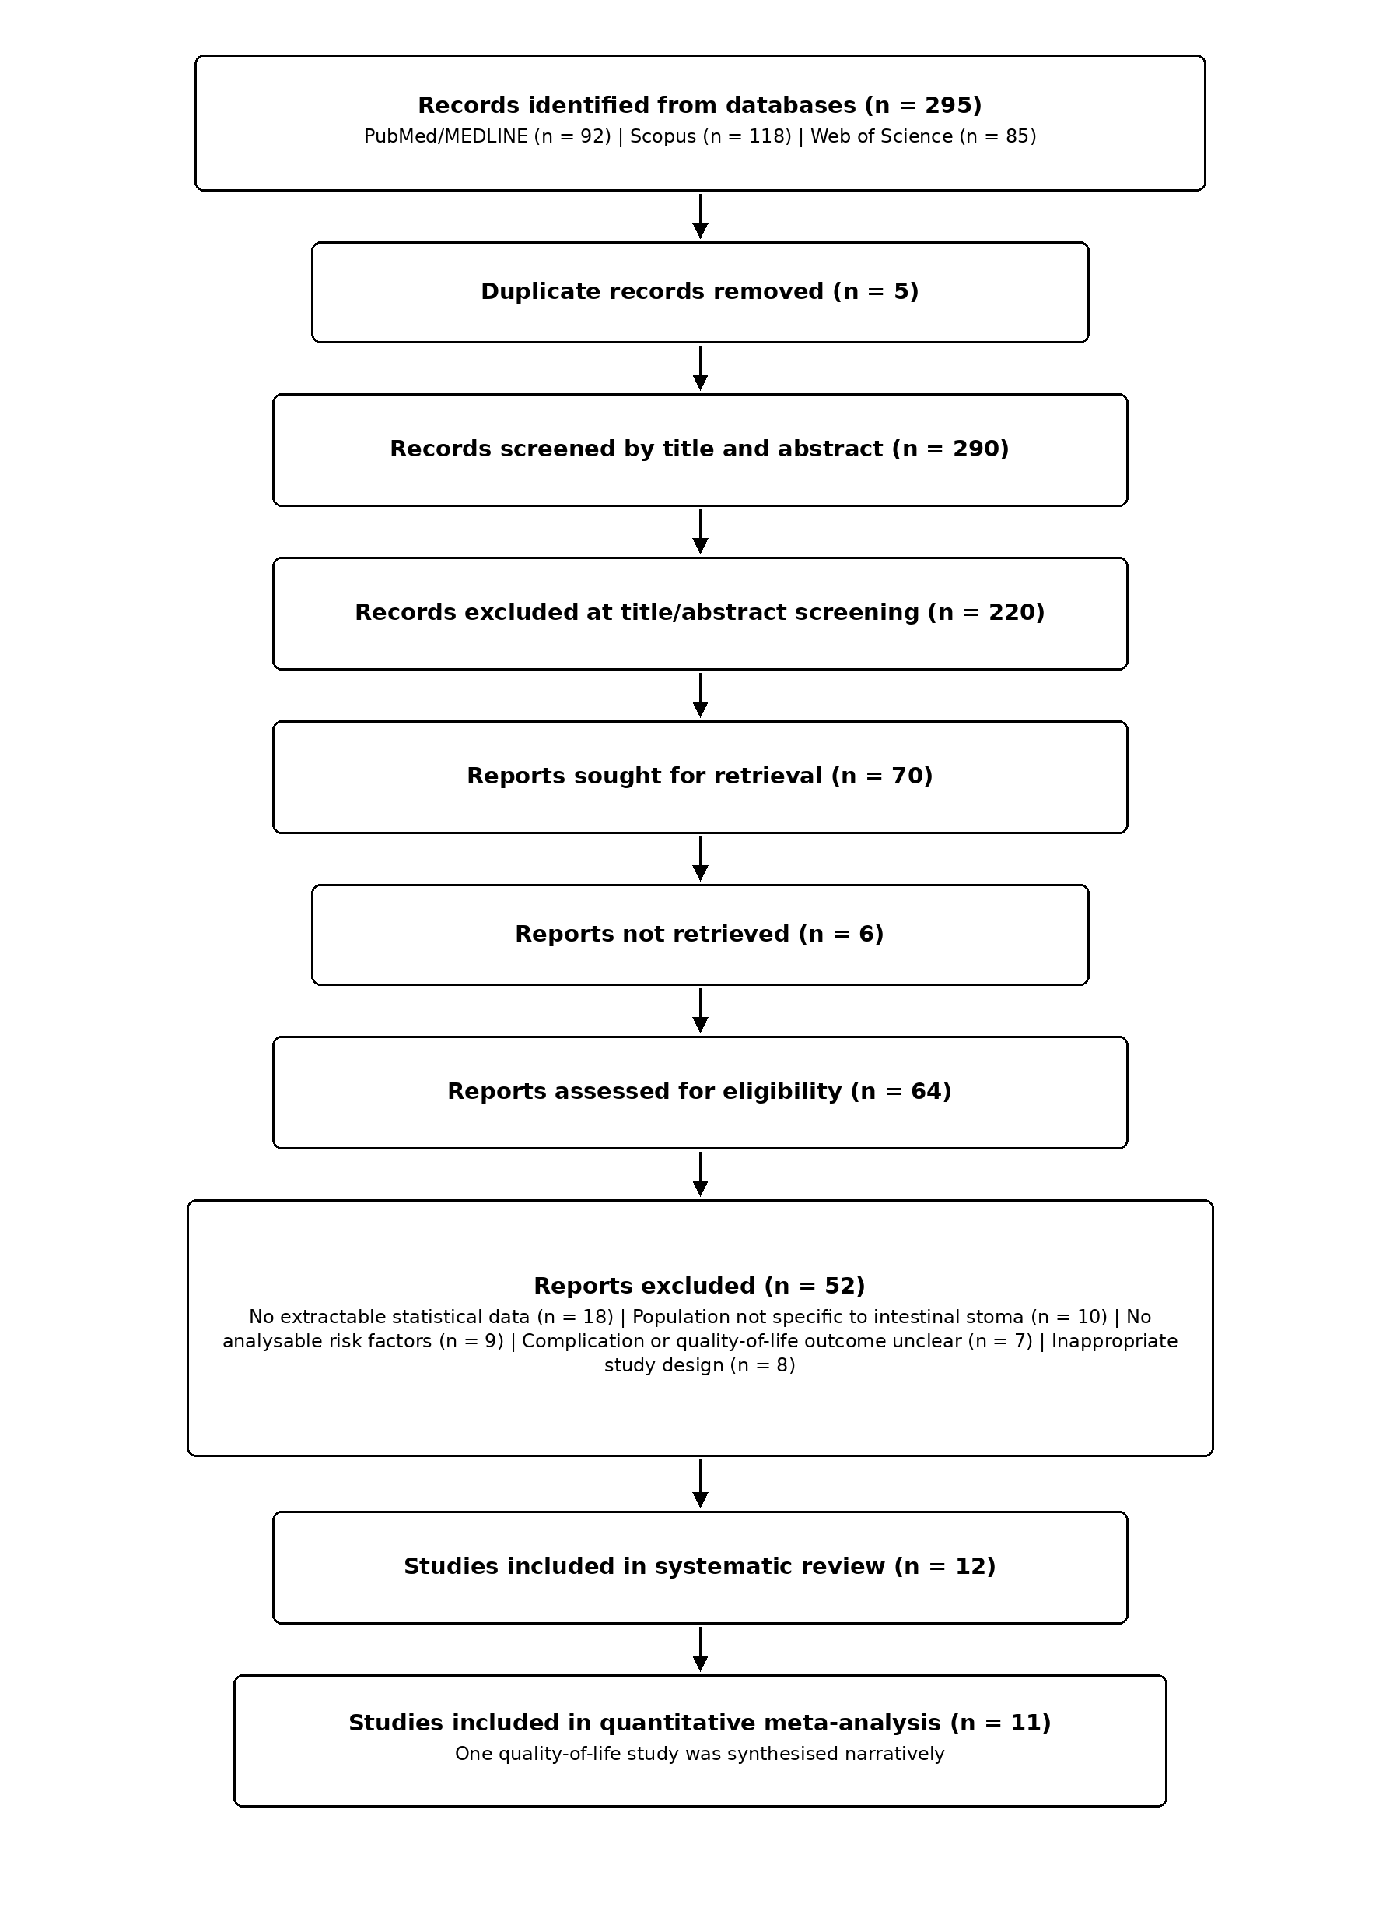
Data were extracted into Microsoft Excel and included author, year, country, study design, sample size, stoma type, risk factors, complication or quality-of-life outcome, and reported statistical estimates, including odds ratio (OR), p-value, and confidence interval (CI) when available. For the exploratory quantitative synthesis, the study-level effects included in the meta-analysis were represented on a common standardised effect scale before pooling. The standardised effect estimates and their corresponding measures of uncertainty were entered into JASP to obtain the pooled standardised effect estimate, confidence interval, study weights, and heterogeneity statistics. Between-study heterogeneity was assessed using Cochran's Q and I². Possible small-study effects or publication bias were explored visually using a funnel plot. Because the included studies evaluated different clinical phases, risk factors, stoma types, and outcome definitions, the pooled estimate was treated as an exploratory statistical summary and was not interpreted as a pooled odds ratio, risk ratio, or other single universal clinical risk measure. Quantitative findings were therefore interpreted together with the outcome-specific narrative synthesis.
For the exploratory quantitative synthesis, the exact standardised effect metric used was the Standardised Effect Size (SES). To ensure comparability across studies reporting different statistical parameters, original study-level effect estimates (such as odds ratios, hazard ratios, and beta coefficients) were transformed onto a common standardised scale before analysis. Direction coding was verified for all included endpoints to ensure that positive values consistently represented an increased risk of postoperative stoma-related complications. The transformed SES and corresponding standard errors for individual studies were entered directly into JASP. The meta-analysis was performed using a random-effects model with the Restricted Maximum Likelihood (REML) estimator. Statistical computations were executed in JASP using the Classical Meta-Analysis module, applying the Knapp and Hartung adjustment for test statistics and confidence intervals. Data extraction and verification were performed independently by three reviewers. Any disagreements regarding data extraction or statistical consistency were resolved through collaborative review of the primary articles and team discussion to achieve consensus.
Methodological quality and risk of bias for the included primary studies were evaluated independently by three reviewers using design-appropriate critical appraisal tools. The Newcastle-Ottawa Scale (NOS) was applied to the cohort studies, while the Joanna Briggs Institute (JBI) Critical Appraisal Checklist was utilised for analytical cross-sectional and descriptive studies. Disagreements in quality scoring were resolved through joint team discussion until consensus was achieved.
Results
Twelve studies were included in the systematic review.^{23–34} Eleven studies contributed to the quantitative meta-analysis, while the cross-sectional quality-of-life study by Liu et al. was summarised narratively. The included studies covered emergency stoma formation, early ostomy complications, comparisons between ileostomy and colostomy, high-output stoma, postoperative ileus and readmission, stoma-related obstruction, morbidity after stoma closure, sigmoid stoma complications after abdominoperineal resection, prediction of early complications, and quality of life among patients with a stoma. Based on the publication years of the 12 included studies, 2021 and 2024 were the most frequent years, with four studies each. Retrospective designs predominated, and early or postoperative stoma complications were the most frequent outcome focus. The distribution of the included studies is summarised in Table III.
Table III. Distribution of included studies by characteristics
Characteristic | Category | No. of studies | Percentage
Publication year | 2019 | 2 | 16.67%
Publication year | 2020 | 1 | 8.33%
Publication year | 2021 | 4 | 33.33%
Publication year | 2024 | 4 | 33.33%
Publication year | 2025 | 1 | 8.33%
Study design | Retrospective cohort/study | 9 | 75.00%
Study design | Retrospective descriptive study | 1 | 8.33%
Study design | Prediction model study | 1 | 8.33%
Study design | Cross-sectional study | 1 | 8.33%
Outcome focus | Early/postoperative stoma complications | 5 | 41.67%
Outcome focus | High-output stoma/postoperative ileus/readmission | 2 | 16.67%
Outcome focus | Stoma-related obstruction | 1 | 8.33%
Outcome focus | Complications after stoma closure | 2 | 16.67%
Outcome focus | Sigmoid stoma complications after abdominoperineal resection | 1 | 8.33%
Outcome focus | Quality of life | 1 | 8.33%

The included studies were conducted in England/Scotland, Turkey, Taiwan, South Korea, Japan, Mexico, and China. Their clinical focus varied considerably. Emergency stoma formation and early ostomy complications were examined in the studies by MacDonald et al. and Ayik et al.^{23–25} Yang et al. compared common complications of protective loop ileostomy and colostomy, whereas Lee et al. and Takeda et al. evaluated high-output stoma, postoperative ileus, readmission, and predictive factors.^{26–28} Maemoto et al. focused on stoma-related obstruction; Kilinc et al. and Vergara-Fernández et al. assessed morbidity after stoma closure; Lv et al. examined sigmoid stoma complications; Ba et al. developed a prediction model for early complications; and Liu et al. evaluated quality of life among colorectal cancer patients with a stoma.^{29–34} Detailed characteristics of the 12 included studies are presented in Table IV.

Table IV. Characteristics of the 12 included studies
Study | Country | Design/sample | Focus | Key findings
MacDonald et al. (2024) | England/Scotland | Multicentre retrospective; emergency stoma patients | Postoperative outcomes/risk factors | Relevant to complications after emergency stoma formation and postoperative clinical risk factors.
Ayik et al. (2024) | Turkey | Retrospective cohort; n=872 | Early ostomy complications | At least one complication occurred in 573 patients; patterns differed between emergency and elective surgery.
Ayik et al. (2020) | Turkey | Retrospective descriptive; n=572 | Ostomy complications and nursing care | Early complications occurred in 56.5%; common problems included peristomal irritant contact dermatitis and mucocutaneous separation.
Yang et al. (2024) | Taiwan | Retrospective cohort; n=410 | Ileostomy vs colostomy | Ileostomy was more often associated with high-output stoma, whereas colostomy was more often associated with stoma retraction.
Lee et al. (2021) | South Korea | Retrospective cohort; n=302 | High-output stoma, ileus, readmission | Postoperative ileus was an independent risk factor for all-cause and ileus-related readmission.
Takeda et al. (2019) | Japan | Retrospective comparative; 151 analysed | High-output ileostomy | High-output syndrome occurred in 36 of 151 patients; predictive factors were assessed using logistic regression.
Maemoto et al. (2021) | Japan | Retrospective; n=155 | Stoma-related obstruction | Stoma-related obstruction occurred in 7.7%; ileal-pouch anal anastomosis was an independent risk factor.
Kilinc et al. (2021) | Turkey | Retrospective descriptive; n=179 | Stoma-closure morbidity | ASA score and coronary artery disease were associated with complications; colostomy was reported as a risk factor for postoperative ileus.
Vergara-Fernández et al. (2019) | Mexico | Retrospective; n=136 | Loop ileostomy closure | Reported risk factors included midline laparotomy, immunomodulator use, familial adenomatous polyposis, age ≥65 years, closure <3 months, and parastomal hernia.
Lv et al. (2024) | China | Observational/retrospective | Sigmoid stoma complications | Evaluated risk factors for sigmoid stoma complications after abdominoperineal resection.
Ba et al. (2025) | China | Retrospective prediction-model study | Early stoma complications | Presented risk factors and a prediction model for early postoperative stoma complications in colorectal cancer.
Liu et al. (2021) | China | Cross-sectional; n=359 | Quality of life; narrative synthesis | Quality of life was generally low; temporary stoma, complications, and receiving stoma care from others were associated with lower scores. This study was not included in the pooled meta-analysis.

Methodological quality appraisal of the 12 included studies identified several methodological limitations across the evidence base. Most included studies used retrospective observational designs, and common concerns involved single-centre data collection, potential residual confounding, retrospective ascertainment of exposures and outcomes, and variability in follow-up and outcome definitions. Studies using multivariable analyses provided stronger adjustment for potential confounding, whereas the prediction-model study was limited by the absence of external validation despite internal validation procedures. The cross-sectional and descriptive studies were considered particularly susceptible to limitations related to temporal inference and confounding. These methodological considerations were taken into account when interpreting the pooled findings. A study-level qualitative appraisal summary is presented in Table V.

Table V. Study-level methodological quality and risk-of-bias appraisal
Study | Design | Key appraisal consideration
MacDonald et al. (2024) | Multicentre retrospective | Retrospective observational design; multicentre setting. Interpret associations with potential residual confounding in mind.
Ayik et al. (2024) | Retrospective cohort | Retrospective cohort design; observational associations remain susceptible to residual confounding.
Ayik et al. (2020) | Retrospective descriptive | Descriptive retrospective design; limited ability to establish temporal or causal relationships.
Yang et al. (2024) | Retrospective cohort | Retrospective observational comparison; findings should be interpreted as associations.
Lee et al. (2021) | Retrospective cohort | Retrospective cohort design; observational associations and residual confounding remain possible.
Takeda et al. (2019) | Retrospective comparative | Retrospective comparative design; interpretation is limited by observational data.
Maemoto et al. (2021) | Retrospective | Retrospective observational design with a relatively modest sample size.
Kilinc et al. (2021) | Retrospective descriptive | Descriptive retrospective design; limited control of potential confounding.
Vergara-Fernández et al. (2019) | Retrospective | Retrospective observational design; causal inference is limited.
Lv et al. (2024) | Observational/retrospective | Retrospective observational design; residual confounding cannot be excluded.
Ba et al. (2025) | Retrospective prediction-model study | Prediction-model study; the manuscript reports absence of external validation despite internal validation.
Liu et al. (2021) | Cross-sectional | Cross-sectional design; temporal relationships cannot be established and confounding may remain.

Eleven studies contributed to the exploratory quantitative meta-analysis displayed in the forest plot. The pooled standardised effect estimate was 1.12 (95% CI 0.60–1.65), with t(10)=4.80 and p<0.001. Between-study heterogeneity was substantial (Q(10)=104.53, p<0.001; I²=86.98%). The funnel plot was not fully symmetrical, with more estimates distributed to the right of the centre line and several points associated with larger standard errors. The quantitative meta-analysis is summarised in Table VI. The forest plot is shown in Figure 2, and the funnel plot is shown in Figure 3.
Table VI. Summary of the exploratory standardised meta-analysis
Parameter | Result
Studies in quantitative meta-analysis | 11
Pooled standardised effect estimate | 1.12 (95% CI 0.60–1.65)
Pooled-effect test | t(10)=4.80, p<0.001
Cochran’s Q | Q(10)=104.53, p<0.001
I² | 86.98%
Funnel-plot observation | Not fully symmetrical

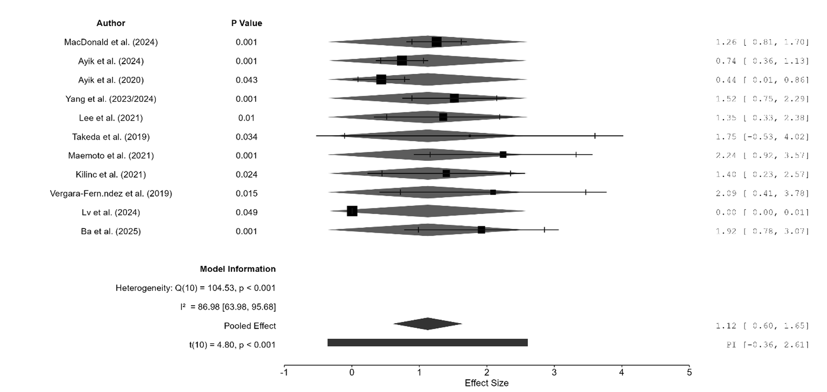

Figure 2. Forest plot of standardised effect estimates in the exploratory meta-analysis of stoma-related outcomes
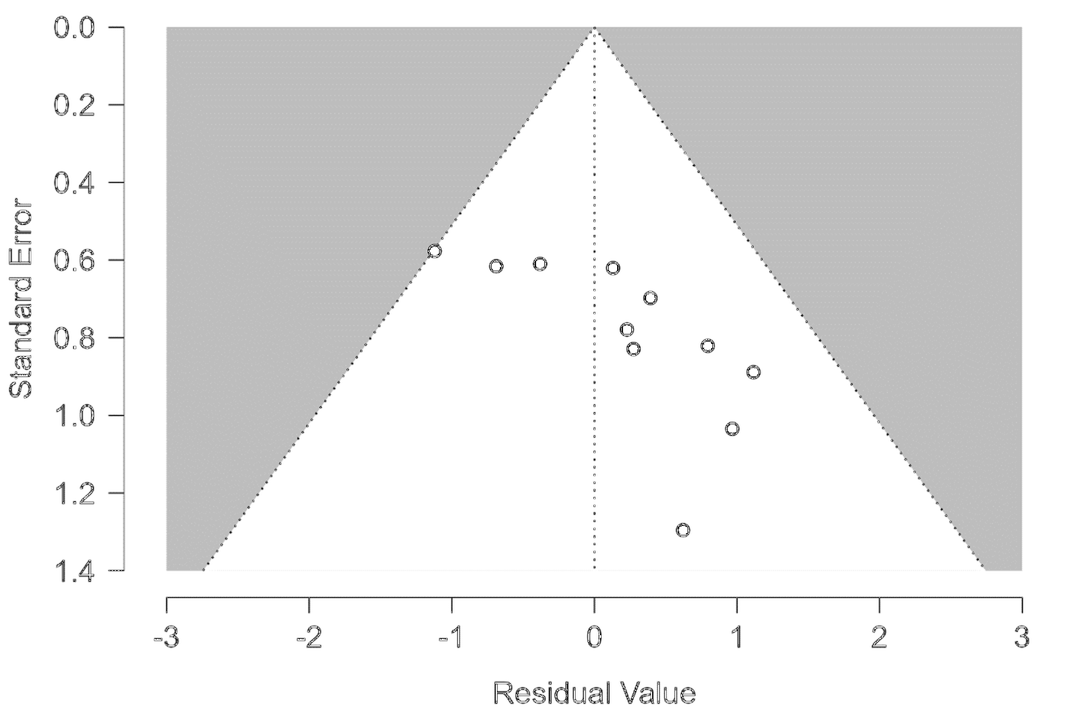
Figure 3. Funnel plot of the exploratory standardised meta-analysis
Discussion
The findings indicate that postoperative complications in patients with intestinal stoma should not be viewed as a single clinical outcome. The included studies addressed different complications and phases of care, ranging from emergency stoma formation and early postoperative morbidity to high-output stoma, obstruction, readmission, stoma closure, and quality of life.23–34 The substantial heterogeneity in the pooled analysis is therefore clinically plausible and limits interpretation of the standardised summary effect as a uniform clinical measure of risk. Standardisation allowed study-level effects to be expressed on a common statistical scale, but it did not make the underlying clinical outcomes equivalent. Consequently, the pooled estimate is best considered as an exploratory quantitative summary that complements, rather than replaces, outcome-specific interpretation.
Risk factors were distributed across patient-related, procedural, anatomical, and stoma-care domains. Malignant disease, comorbidity, loop ostomy, female sex, neoadjuvant therapy, ileostomy, low stoma height, obesity, and emergency surgery were associated with selected complications in the included literature.^{23,24} Broader systematic evidence has likewise identified multiple patient-level and procedural risk factors following stoma formation.³⁶
The distribution of risk factors across different clinical phases also has practical implications for interpretation. Factors operating at stoma formation, such as emergency surgery, comorbidity, obesity, stoma configuration, and stoma height, are conceptually different from factors associated with later obstruction, readmission, or morbidity at closure.23–31 This distinction helps explain why a common standardised scale can facilitate statistical summarisation without implying that the underlying causal pathways are interchangeable. Previous systematic evidence has similarly identified a broad range of patient-level and procedural factors after stoma formation, supporting the need to interpret risk in relation to the timing and type of complication rather than as a single undifferentiated endpoint.36
Ileostomy and colostomy showed different complication profiles. Protective colostomy was more strongly associated with stoma retraction in one included study, whereas ileostomy was linked to high-output stoma, fluid imbalance, postoperative ileus, and readmission in other studies.^{26–28} Evidence comparing preventive loop ileostomy and colostomy similarly suggests that individual complications differ by procedure rather than consistently favouring one stoma type across all outcomes.³⁷
These procedure-specific patterns are clinically relevant because the consequences of a stoma extend beyond the index operation. High-output stoma may contribute to fluid and electrolyte disturbance, postoperative ileus and subsequent readmission, whereas retraction, prolapse and other mechanical complications can interfere with appliance fitting and long-term stoma management.26–28,37 The included studies therefore support a phase-based interpretation of morbidity: early technical and skin complications, intermediate problems related to output or obstruction, and later morbidity related to long-term stoma function or closure. This framework provides a more clinically coherent interpretation of the heterogeneous evidence than treating every adverse outcome as the same event.
Late and skin-related complications further broaden the clinical spectrum. Parastomal hernia has been associated with worse health-related quality of life, while peristomal Candida infection has been examined as a risk factor for surgical-site infection after stoma closure.12,13 In rectal cancer patients, loop stoma, stoma height below 10 mm, chemotherapy, and diabetes mellitus have been associated with peristomal skin disorders or worsening skin conditions.11 Earlier clinical guidance also emphasised that postoperative stoma care and peristomal skin complications are central components of long-term management.35 These findings reinforce that complication burden is not limited to surgical events; skin integrity, leakage control, appliance adherence and self-care can influence daily functioning after discharge.
Quality of life represents a distinct but related dimension of stoma outcomes. The included cross-sectional study evaluated quality of life among colorectal cancer patients living with a stoma and found lower scores in patients with temporary stomas, complications, or reliance on others for stoma care.34 Broader evidence indicates that peristomal skin problems, leakage, discomfort, and difficulties with self-care may extend into psychological, social, and functional limitations.38,39 This relationship is clinically important because a complication that appears minor from a purely surgical perspective may have a disproportionate effect on body image, social confidence, work, sleep or willingness to participate in routine activities. Quality-of-life findings should therefore be interpreted as patient-centred outcomes that interact with postoperative morbidity rather than as direct equivalents of complication-risk estimates.
The exploratory quantitative synthesis yielded a pooled standardised effect estimate across the included studies. However, this estimate should not be interpreted as a single clinical risk ratio because the studies differed substantially in design, stoma type, patient population, clinical phase, risk factor, and outcome definition. The high heterogeneity reflects these genuine clinical and methodological differences despite expression of study-level effects on a common standardised scale. The observed funnel-plot asymmetry should also be interpreted cautiously because funnel-plot patterns may be influenced by clinical heterogeneity, differences in precision, and small-study effects. The quantitative result is therefore most informative when read together with the individual study findings and the clinical patterns described in the narrative synthesis.
The clinical continuum represented in the included studies also suggests that the meaning of a risk factor depends on when the outcome is measured. An exposure associated with an early peristomal skin complication may not have the same relevance for later obstruction, readmission, or morbidity after stoma closure.23–31 Likewise, temporary and permanent stomas create different periods of exposure to appliance-related problems, skin injury, dietary adaptation, and self-care demands.34–39 Interpreting the evidence according to clinical phase therefore helps prevent overgeneralisation from one complication category to another. It also explains why the high heterogeneity observed in the meta-analysis is not simply a statistical inconvenience but a reflection of real differences in patient populations, operative indications, stoma configurations, follow-up periods, and outcome definitions. For this reason, the present quantitative synthesis is most useful as a broad signal of between-study effect direction and magnitude, while individual study estimates remain necessary for clinical interpretation. Future primary studies would be easier to combine if they used clearer definitions of early and late complications, consistently reported effect estimates with uncertainty measures, and distinguished outcomes occurring during stoma formation, the period of living with a stoma, and the closure phase. These reporting improvements would strengthen subsequent outcome-specific meta-analyses without requiring clinically distinct complications to be treated as equivalent.
A strength of this review is the use of three major bibliographic databases together with a PRISMA-based study-selection process and a synthesis that considered both clinical complications and patient-centred outcomes. The inclusion of studies from several countries and different phases of stoma care broadens the clinical context of the review. At the same time, this breadth is the principal reason the pooled standardised effect should remain exploratory. The review therefore provides value primarily by mapping the pattern of complications and associated factors across the stoma-care continuum while presenting the quantitative summary with explicit limits on clinical interpretation.
This review has several limitations. PubMed/MEDLINE, Scopus, and Web of Science were searched, but Embase and the Cochrane Library were not included. Quality-of-life studies were fewer than studies of clinical complications. Subgroup analysis, sensitivity analysis, and meta-regression were not undertaken because few studies were clinically comparable within individual outcome categories. In addition, the pooled standardised effect represents an exploratory statistical summary across heterogeneous stoma-related outcomes and should not be interpreted as an outcome-specific clinical effect size. The search was restricted to English and/or Indonesian articles and required full-text availability. These limitations reduce confidence in the pooled estimate and reinforce the need to interpret outcome-specific findings alongside the quantitative summary.
Methodological appraisal also indicated that the evidence base was predominantly derived from retrospective observational studies. Consequently, residual confounding, retrospective ascertainment of clinical variables, single-centre sampling, and variation in follow-up and outcome definitions could not be completely excluded. These limitations should be considered when interpreting both the individual study findings and the exploratory pooled estimate.
Conclusion
Complications after intestinal stoma formation varied across the postoperative course and included early stoma complications, peristomal skin problems, high-output stoma, stoma-related obstruction, readmission, and morbidity after stoma closure. Twelve studies were included in the systematic review and 11 contributed to the quantitative meta-analysis. The exploratory meta-analysis yielded a pooled standardised effect estimate of 1.12 (95% CI 0.60–1.65; t(10)=4.80, p<0.001), with substantial between-study heterogeneity (I²=86.98%). This pooled estimate represents a standardised statistical summary rather than a single universal clinical measure of risk and should therefore be interpreted alongside the outcome-specific findings. Stoma outcomes differed according to patient characteristics, stoma type, clinical phase, and outcome definition, while quality of life remained an important complementary patient-centred outcome.
Declarations
AUTHORS' CONTRIBUTION: LR conceived the study, contributed to the study design, literature search, data interpretation, and preparation of the manuscript. KAE contributed to the study methodology, interpretation of findings, critical review, and revision of the manuscript. RBL contributed to data interpretation, critical review of the scientific content, and revision of the manuscript. All authors reviewed and approved the final version of the manuscript.
COMPETING INTEREST: The authors declared no conflict of interest.
FUNDING: This research received no specific grant from any funding agency in the public, commercial, or not-for-profit sectors.
PATIENTS' CONSENT: Not applicable; this review used data from previously published studies and did not enrol patients directly.
ETHICAL APPROVAL: Ethical approval was not required because this systematic review and meta-analysis used exclusively previously published data and did not involve direct recruitment of human participants or collection of identifiable individual-level data.
References
1. Qassim T, Saeed MF, Qassim A, Al-Rawi S, Al-Salmi S, Salman MT, et al. Intestinal stomas-Current practice and challenges: An institutional review. Euroasian J Hepatogastroenterol 2023;13:115-9. doi:10.5005/jp-journals-10018-1404.
2. Elnaim AL, Wong M, Sagap I. Intestinal stomas; basics, complications and controversy: systematic review. Acad Med Surg. Published online December 7, 2024. doi:10.62186/001c.127121.
3. Ambe PC, Kugler CM, Breuing J, Grohmann E, Friedel J, Hess S, et al. The effect of preoperative stoma site marking on risk of stoma-related complications in patients with intestinal ostomy: a systematic review and meta-analysis. Colorectal Dis 2022;24:904-17. doi:10.1111/codi.16118.
4. Nozawa H, Sasaki S, Hayashi C, Kawasaki A, Sasaki K, Murono K, et al. Preoperative stoma site marking reduces postoperative stoma-related complications in emergency surgery: a single center retrospective cohort study. Scand J Surg 2024;113:40-9. doi:10.1177/14574969231186282.
5. Dellafiore F, Caruso R, Bonavina L, Udugampolage NS, Villa G, Russo S, et al. Risk factors and pooled incidence of intestinal stoma complications: systematic review and meta-analysis. Curr Med Res Opin 2022;38:1103-13. doi:10.1080/03007995.2022.2081455.
6. Gan JX, Liu HP, Chen K. Prevalence and pooled risk factors of stoma outlet obstruction after colorectal surgery with diverting ileostomy: a systematic review and meta-analysis. Int J Colorectal Dis 2025;40:119. doi:10.1007/s00384-025-04862-5.
7. Toffaha A, Badr A, Al-Dhaheri M, Aleter A, Latif E, Kurer M, et al. Risk factors for stoma outlet obstruction: systematic review and meta-analysis. Langenbecks Arch Surg 2025;410:317. doi:10.1007/s00423-025-03892-5.
8. Zhou L, Qin Z, Wang L. Risk factors and incidence of non-closure stoma in patients with anterior resection of rectal cancer with temporary stoma: a systematic review and meta-analysis. Eur J Surg Oncol 2023;49:107120. doi:10.1016/j.ejso.2023.107120.
9. Brady RRW, Sheard D, Howard K, Vestergaard M, Boisen EB, Mather R, et al. The prevalence of leakage, peristomal skin complications and impact on quality of life in the first year following stoma surgery. Nurs Rep 2025;15:107. doi:10.3390/nursrep15030107.
10. Poliani A, Marcomini I, Butti P, Nedesca ED, Manara DF, Villa G. Stoma leakage: prevalence, associated factors, and assessment tools-a scoping review. Nurs Rep 2026;16:46. doi:10.3390/nursrep16020046.
11. Shiraishi T, Ogawa H, Katayama C, Osone K, Okada T, Katoh R, et al. Association of chemotherapy and stoma features with peristomal skin disorders in rectal cancer patients. Sci Rep 2025;15:42214. doi:10.1038/s41598-025-26387-1.
12. Glynn J, Hollingworth W, Harris J, Mohiuddin S, Ellis L, Reeves BC, et al. The impact of parastomal hernia on quality of life using data from the CIPHER prospective cohort study. Eur J Health Econ 2025;26:1209-18. doi:10.1007/s10198-025-01768-5.
13. Jose A, Kothari R, Sharma DB, Sharma D. Incidence and impact of peristomal candidiasis on outcomes after intestinal stoma closure: a prospective study. Trop Doct 2025;55:121-3. doi:10.1177/00494755251329636.
14. Zeng Z, Hu Y, Hou S, Yang R, Shi Z, Li X. Risk factors for complications after infantile enterostomy: development of a clinical prediction model. Front Public Health 2025;13:1566789. doi:10.3389/fpubh.2025.1566789.
15. Zewude WC, Derese T, Suga Y, Teklewold B. Quality of life in patients living with stoma. Ethiop J Health Sci 2021;31:993-1000. doi:10.4314/ejhs.v31i5.11.
16. Leite Junior VdO, Vieira GG, Lima KS, Costa SM, Carvalho ARBd, Soeiro VMdS, et al. Quality of life and its determinants in older adults with intestinal stomas: a cross-sectional study. Int J Environ Res Public Health 2025;22:375. doi:10.3390/ijerph22030375.
17. Lupo R, Rubbi I, Barletta A, Mele C, Lezzi A, Botrugno I, et al. Quality of life and psychophysical consequences in individuals with intestinal stoma: an observational study. Int J Environ Res Public Health 2025;22:1327. doi:10.3390/ijerph22091327.
18. Açil HC, Yilmaz AÇ, Aygin D. The effect of recovery status and life conditions on the quality of life in colorectal cancer patients with stoma: a path analysis. Front Psychol 2025;16:1693626. doi:10.3389/fpsyg.2025.1693626.
19. Díaz-Sánchez C, Rodríguez-Muñoz PM, Navarro-López V, Carmona-Torres JM, Sánchez-Gil A, Sánchez-González JL, et al. Impact of ostomy on quality of life in patients with colorectal cancer: a systematic review and meta-analysis. Healthcare (Basel) 2026;14:444. doi:10.3390/healthcare14040444.
20. Sritan S. Factors contributing to the quality of life among Thai patients diagnosed with colorectal cancer with a stoma: an integrative review. J Adv Nurs 2023;79:1-14. doi:10.1111/jan.15460.
21. Page MJ, McKenzie JE, Bossuyt PM, Boutron I, Hoffmann TC, Mulrow CD, et al. The PRISMA 2020 statement: an updated guideline for reporting systematic reviews. BMJ 2021;372:n71. doi:10.1136/bmj.n71.
22. Higgins JPT, Thomas J, Chandler J, Cumpston M, Li T, Page MJ, et al. Cochrane Handbook for Systematic Reviews of Interventions. Version 6.5. Cochrane; 2024. Available from: https://www.cochrane.org/authors/handbooks-and-manuals/handbook/current.
23. MacDonald S, Wong L-S, Ng HJ, Hastings C, Ross I, Quasim T, et al. Post-operative outcomes and identification of risk factors for complications after emergency intestinal stoma surgery: a multi-centre retrospective study. Colorectal Dis 2024;26:994-1003. doi:10.1111/codi.16947.
24. Ayik C, Bişgin T, Cenan D, Manoğlu B, Özden D, Sökmen S. Risk factors for early ostomy complications in emergency and elective colorectal surgery: a single-center retrospective cohort study. Scand J Surg 2024;113:50-9. doi:10.1177/14574969231190291.
25. Ayik C, Özden D, Cenan D. Ostomy complications, risk factors, and applied nursing care: a retrospective, descriptive study. Wound Manag Prev 2020;66:20-30. doi:10.25270/wmp.2020.9.2030.
26. Yang Y-W, Huang S-C, Cheng H-H, Chang S-C, Jiang J-K, Wang H-S, et al. Protective loop ileostomy or colostomy? A risk evaluation of all common complications. Ann Coloproctol 2024;40:580-7. doi:10.3393/ac.2022.00710.0101.
27. Lee N, Lee SY, Kim CH, Kwak HD, Ju JK, Kim HR. The relationship between high-output stomas, postoperative ileus, and readmission after rectal cancer surgery with diverting ileostomy. Ann Coloproctol 2021;37:44-50. doi:10.3393/ac.2020.08.03.
28. Takeda M, Takahashi H, Haraguchi N, Miyoshi N, Hata T, Yamamoto H, et al. Factors predictive of high-output ileostomy: a retrospective single-center comparative study. Surg Today 2019;49:482-7. doi:10.1007/s00595-018-1756-2.
29. Maemoto R, Tsujinaka S, Miyakura Y, Fukuda R, Kakizawa N, Takenami T, et al. Risk factors and management of stoma-related obstruction after laparoscopic colorectal surgery with diverting ileostomy. Asian J Surg 2021;44:1037-42. doi:10.1016/j.asjsur.2021.01.002.
30. Kilinc G, Ustun M, Tuncer K, Sert I. Risk factors for the morbidity and mortality of stoma closure. J Coll Physicians Surg Pak 2021;31:1085-8. doi:10.29271/jcpsp.2021.09.1085.
31. Vergara-Fernández O, Trejo-Avila M, Salgado-Nesme N. Multivariate analysis of risk factors for complications after loop ileostomy closure. Cir Cir 2019;87:337-46. doi:10.24875/CIRU.18000611.
32. Lv Q, Yuan Y, Xiang Z. Analysis of risk factors for the sigmoid stoma complications in patients after abdominoperineal resection surgery: an observational study. Medicine (Baltimore) 2024;103:e38751. doi:10.1097/MD.0000000000038751.
33. Ba M-Q, Zheng W-L, Zhang Y-L, Zhang L-L, Chen J-J, Ma J, et al. Construction of a nomogram prediction model for early postoperative stoma complications of colorectal cancer. World J Gastrointest Surg 2025;17:100547. doi:10.4240/wjgs.v17.i1.100547.
34. Liu H, Zhu X, Yu J, He P, Shen B, Tang X, et al. The quality of life of patients with colorectal cancer and a stoma in China: a quantitative cross-sectional study. Adv Skin Wound Care 2021;34:302-9. doi:10.1097/01.ASW.0000744348.32773.b9.
35. Steinhagen E, Colwell J, Cannon LM. Intestinal stomas-postoperative stoma care and peristomal skin complications. Clin Colon Rectal Surg 2017;30:184-92. doi:10.1055/s-0037-1598159.
36. Chan MS, Moore Z, Patton D, McNamara D, O’Connor T, Avsar P. A systematic review of patient risk factors for complications following stoma formation among adults undergoing colorectal surgery. Int J Colorectal Dis 2023;38:238. doi:10.1007/s00384-023-04523-5.
37. Ge Z, Zhao X, Liu Z, Yang G, Wu Q, Wang X, et al. Complications of preventive loop ileostomy versus colostomy: a meta-analysis, trial sequential analysis, and systematic review. BMC Surg 2023;23:235. doi:10.1186/s12893-023-02129-w.
38. D’Ambrosio F, Pappalardo C, Scardigno A, Maida A, Ricciardi R, Calabrò GE. Peristomal skin complications in ileostomy and colostomy patients: what we need to know from a public health perspective. Int J Environ Res Public Health 2022;20:79. doi:10.3390/ijerph20010079.
39. Guerra E, Denti FC, Di Pasquale C, Caroppo F, Angileri L, Cioni M, et al. Peristomal skin complications: detailed analysis of a web-based survey and predictive risk factors. Healthcare (Basel) 2023;11:1823. doi:10.3390/healthcare11131823.

